Sun Sensor Hardware Description
Clayton Gumbrell
25 December 2008
Hardware Version 1.0

Description

PCB Layout
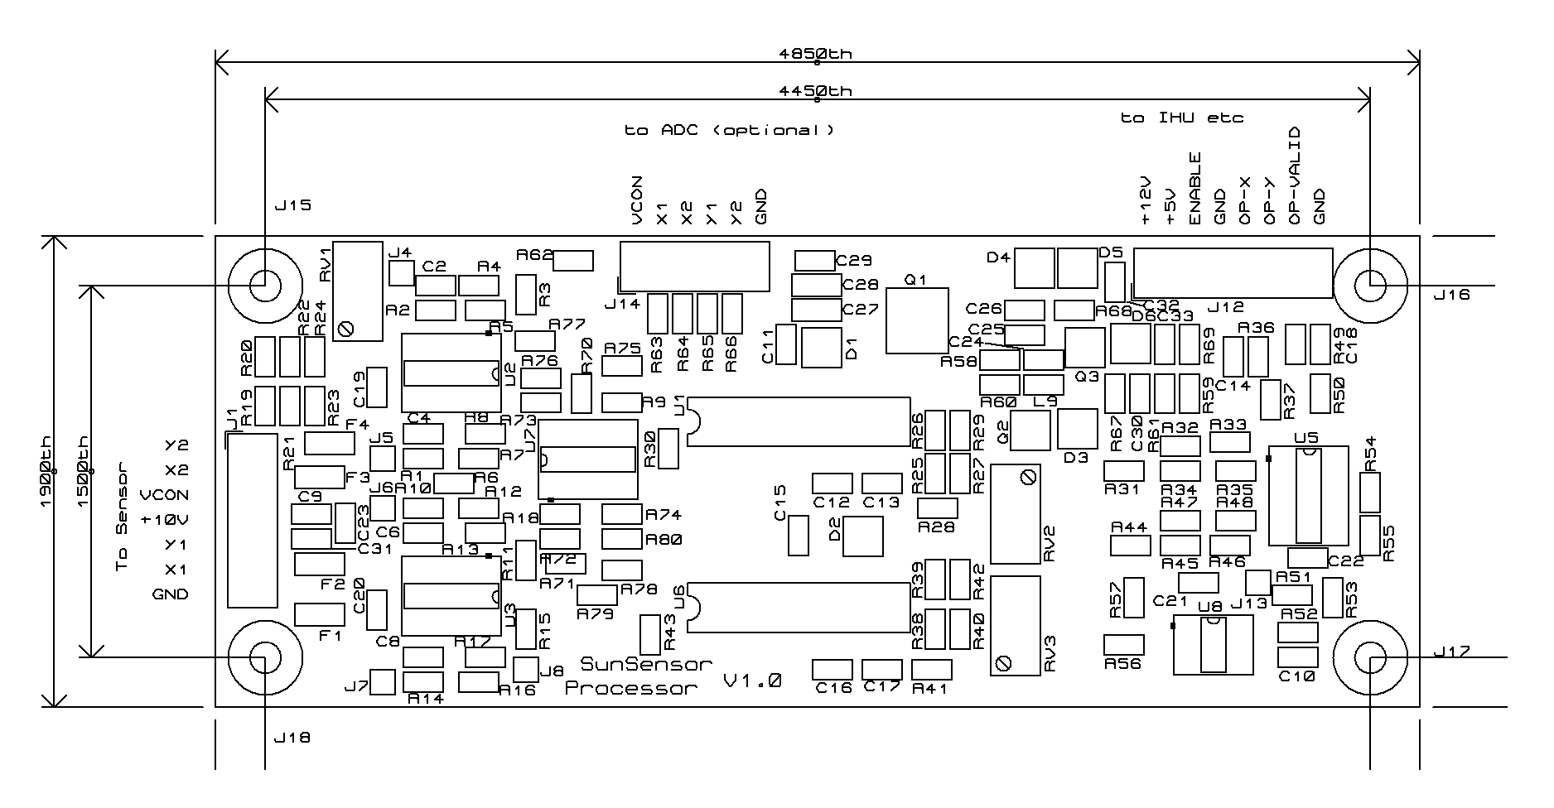

PCB Connections
JX is the X connections
Connections | Signal | Description
J1 – 1 | Y2 | Sensor ‘Y2’ Anode
J1 – 2 | X2 | Sensor ‘X2’ Anode
J1 – 3 | VCON | Sensor Cathode
J1 – 4 | +10V | Switches V+ rail (not used)
J1 – 5 | Y1 | Sensor ‘Y1’ Anode
J1 – 6 | X1 | Sensor ‘X1’ Anode
J1 – 7 | GND | Ground (0V) (not used)
J12 – 1 | +12V | +12V supply in
J12 – 2 | +5V | +5V supply in
J12 – 3 | ENABLE | SunSensor Enable (active low)
J12 – 4 | GND | Ground (0V)
J12 – 5 | OP-X | X Output. 1.25V corresponds to X=0
J12 – 6 | OP-Y | Y Output. 1.25V corresponds to Y=0
J12 – 7 | OP-VALID | 1.25V = Outputs invalid. 2.5V = Outputs valid
J12 – 8 | GND | Ground (0V)
J14 |  | Sensor channel voltages – not used

